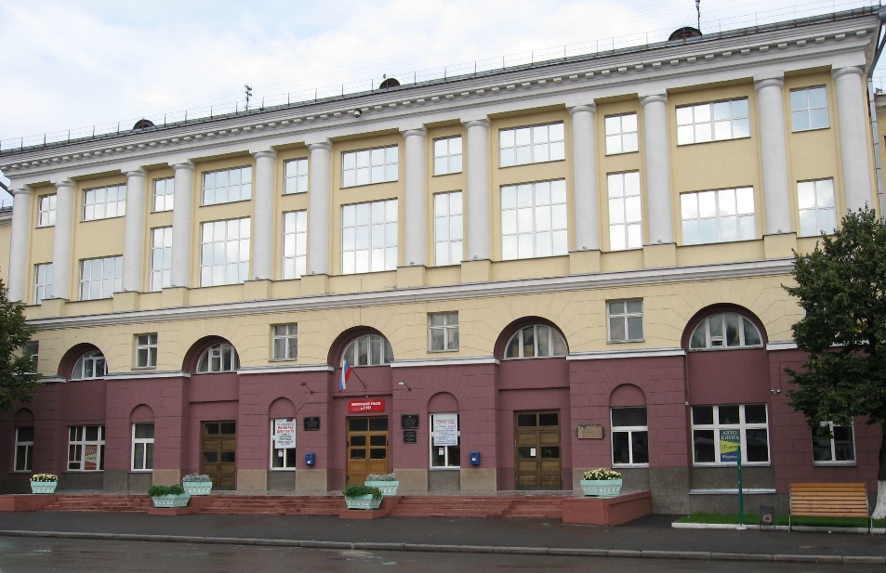
T.F. Gorbachev Kuzbass State Technical University

Information Letter
Vth International Innovative Mining Symposium
19-21 October, 2020
650000 Vesennya Street, 28, Kemerovo, Russian Federation
http://science.kuzstu.ru/event/event-reports/conference/sym/5-eng

PhD students, teachers, scientists, research workers of higher educational institutions, research institutes and industrial enterprises are invited to participate in the conference. Research papers by the participants will be peer-reviewed and considered for publication in “Environment, Energy and Earth Sciences (E3S) Web of Conferences” journal indexed in Web of Science and Scopus.

TOPICS AND SECTIONS OF THE CONFERENCE

1. Environment Saving Mining Technologies:
- innovation-driven development of open pit mining geo-technology;
- progressive underground mining technologies;
-issues of geological exploration;
- innovations in solid commercial minerals processing;
- problems of natural and technogenic arrays’ stability.
2. Environment Problems in Mining Regions:
- reduction of anthropogenic impact on ecosystems of mining areas;
- new technologies for safety of mining operations providing;
- mine and quarry water and air purifying technologies;
innovative “post-mining” and reclamation;
- monitoring of environmental problems in mining regions.
3. Innovations in Mining Machinery:
- robotization and unmanned mining technologies;
- underground equipment for geo-winchesters;
- innovative tools for rocks destruction;
- prospects of mining operations integrated mechanization;
- innovative mining equipment.
4. Mining Regions’ Sustainable Development:
- theoretical and practical issues of economy and management of natural resources;
- social welfare in old-industrial and mining regions;
- strategies for socio-economic development and the new industrialization of mining regions;
- investment risks in mining operations;
- human capital development in mining;
- determinants of mining education globalization.

Important dates
1. Registration Deadline: 21 September, 2020.
3. Papers submission Deadline: 18 May, 2020.
3. Author Notification Date: 09 June, 2020.

The fee for publication 100 euro.
The payment is done after the author is notified of the acceptance for publication.

PROGRAM COMMITTEE
- Alexandr Myaskov, Dr.Sc., Prof., National University of Science and Technology MISiS, Moscow, Russia
- Alexey Khoreshok A. Dr.Sc., Prof., Director of Mining Institute, T.F. Gorbachev Kuzbass State Technical University, Kemerovo, Russia
- Andrey A. Krechetov, Acting Rector of T.F. Gorbachev Kuzbass State Technical University, Kemerovo, Russia
- Asmelash Abay, PhD, Assoc. Prof., College of Natural and Computational Sciences, Mekelle University, Ethiopia
- Demirel Nuray, PhD, Middle East Technical University, Turkey
- Evgeny P. Yutiaev, General Director of JSC “SUEK-Kuzbass”
- Magerram Gasanov, Dr.Sc. in Economics, Prof., National Research Tomsk Polytechnic University, Tomsk, Russia
- Jurgen Kretschmann, Prof., Director TFH Georg Agricola, Bochum, Germany
- Kantovich Leonid I., Dr.Sc., Head of Mining Machines and Aggregates Department, National University of Science and Technology MISiS, Moscow, Russia
- Juraj Yanocko, Prof., Dr.Sc., Technical University of Kosice, Kosice, Slovak Republic
- Michal Cehlár, PhD, Prof. Ing., Dean of Mining Faculty, Technical University of Kosice, Kosice, Slovak Republic
- Oleg Misnikov, Dr.Sc., Dean, Tver State Technical University, Tver, Russia
- Oleg Litvin, PhD, Chairman of Open Pit Mining Department T.F. Gorbachev Kuzbass State Technical University
- Seroni Anyona, PhD, Assoc. Prof., Jomo Kenyatta University of Agriculture and Technology, Kenya
- Stefan Vöth, Dr.-Ing., Prof., TFH Georg Agricola, Bochum, Germany
- Vladimir Aksenov, Dr.Sc., Prof., Head of Laboratory of Mining Geotechnical Engineering of the Institute of Coal of SB RAS, Kemerovo, Russia
- Yunliang Tan, PhD, Dean of Mining and Safety Engineering College, Shandong University of Science and Technology, Qingdao, China

ORGANIZING COMMITTEE
- Svetlana Kostyuk, Vice-Rector for Science and Development of T.F. Gorbachev Kuzbass State Technical University, Kemerovo, Russia
- Svetlana Grigashkina, PhD, Head of Science Department, T.F. Gorbachev Kuzbass State Technical University, Kemerovo, Russia
- Inna Pevneva, PhD, Head of International Department, T.F. Gorbachev Kuzbass State Technical University, Kemerovo, Russia
- Sergey Zhironkin, Dr.Sc., Prof. of Open Pit Mining Department, T.F. Gorbachev Kuzbass State Technical University, Kemerovo, Russia
- Oleg Ostanin, Science Department, T.F. Gorbachev Kuzbass State Technical University, Kemerovo, Russia
Address:
T.F. Gorbachev Kuzbass State Technical University, 650000 Vesennya Street, 28, Kemerovo, Russian Federation

Chair of the Organizing Committee: Svetlana Kostyuk, PhD, Assoc. Prof.
Conference Secretary: Inna Pevneva, PhD, Head of International Department, T.F. Gorbachev Kuzbass State Technical University, Kemerovo, Russia
E-mail: pevnevaiv@kuzstu.ru

PUBLICATION OF SUBMITTED PAPERS
The participants of the conference may publish their papers in “Environment, Energy and Earth Sciences (E3S) Web of Conferences” journal in English (indexed in Web of Science and Scopus). The publishing period is up to six months after the date of Conference.
URL: http://www.e3s-conferences.org/

PAPER REQUIREMENTS
To participate in the conference you should send an E-Mail with you contact information and attach a file of your paper to: conference@kuzstu.ru

The paper should be formatted in accordance with the template (Appendix 1).

The file name of the attached paper should be the name of the first author (for example, Smith A.doc).

PAPERS FOR THE CONFERENCE PROCEEDINGS

The language of the Symposium is English.
The paper should contain an abstract in English (max. 200 words).
The paper should be of 6 to 7 pages. One paper shouldn’t have more than five authors.
The text should be typed in Word 2007/2003. The text can be illustrated with diagrams and tables. All the illustrations must be performed in black-and-white color.
The paper should have sections such as Abstract, Introduction, Results and Discussion, Conclusion, etc.
References should be made in accordance with Publishers requirements (see Appendix 1). References should be made only to the sources from international journals.
The number of references in the list of references should not be less than 10;
Self-citations should not exceed 5%.
The organizing committee may refuse the papers which do not correspond to the topics of the conference or are improperly formatted.

APPENDIX 1
Web of Conferences – 170 x 250 mm paper size, one column format
Isaline Boulven^{1,,} Isabelle Houlbert² , and Agnès Henri¹
¹EDP Sciences, Editorial Department, 91944 Les Ulis Cedex A, France
²EDP Sciences, Production Department, 91944 Les Ulis Cedex A, France
Abstract. You should leave 8 mm of space above the abstract and 10 mm after the abstract. The heading Abstract should be typed in bold 9-point Arial. The body of the abstract should be typed in normal 9-point Times in a single paragraph, immediately following the heading. The text should be set to 1 line spacing. The abstract should be centred across the page, indented 17 mm from the left and right page margins and justified. It should not normally exceed 200 words.
1 Page layout
Use 170 x 250 mm paper size (W x H mm) and adjust the margins to those shown in the Table 1. The final printed area will be 130 x 210 mm. Do not add any page numbers.
Table 1. Setting Word’s margins.
Margin | mm
Top | 24
Bottom | 16
Left | 20
Right | 20
1.1 Formatting the title, authors and affiliations
1.1.1 Formatting the title
The title is set in bold 16-point Arial, justified. The first letter of the title should be capitalised with the rest in lower case. You should leave 22 mm of space above the title and 6 mm after the title.
1.1.2 Formatting author names and author affiliations
The style for the names is First Names, typed in italic 10-point Times, then Last Name, typed in 10-point Times, with a comma after all except the last author, which is separated by comma + “and”. Do not use academic titles.
Affiliations of authors should be typed in 9-point Times. They should be preceded by a numerical superscript corresponding to the same superscript after the name of the author concerned. Please ensure that affiliations are as full and complete as possible and include the country.
1.2 Formatting the text
The text of your paper should be formatted as follows:
- 10-point Times, Times Roman or Times New Roman.
- The text should be set to single line spacing.
- Paragraphs should be justified.
- The first paragraph after a section or subsection should not be indented; subsequent paragraphs should be indented by 5 mm.
The use of sections to divide the text of the paper is optional and left as a decision for the author. Where the author wishes to divide the paper into sections the formatting shown in Table 2 should be used.
Table 2. Formatting sections, subsections and subsubsections.
 | Font | Spacing | numbering
Section | 12-point Arial bold | 6 mm before 3 mm after | 1, 2, 3, etc.
subsection | 10-point Arial bold | 6 mm before 3 mm after | 1.1, 1.2, 1.3, etc.
subsubsection | 10-point Arial Italic | 6 mm before 3 mm after | 1.1.1, 1.1.2, 1.1.3, etc.
2 Figures and tables
Figures and tables, as originals of good quality and well contrasted, are to be in their final form, ready for reproduction, pasted in the appropriate place in the text. Try to ensure that the size of the text in your figures is approximately the same size as the main text (10 point). Try to ensure that lines are no thinner than 0.25 point.
2.1 Captions/numbering
Captions should be typed in 9-point Times. They should be centred above the tables and flush left beneath the figures.
2.2 Positioning
Place the figure as close as possible after the point where it is first referenced in the text. If there is a large number of figures and tables it might be necessary to place some before their text citation.
Fig. 1. Caption of the Figure 1. Below the figure.
2.3 Colour illustrations
You are free to use colour illustrations for the online version of the proceedings but any print version will be printed in black and white unless special arrangements have been made with the conference organiser. Please check whether or not this is the case. If the print version will be black and white only, you should check your figure captions carefully and remove any reference to colour in the illustration and text. In addition, some colour figures will degrade or suffer loss of information when converted to black and white, and this should be taken into account when preparing them.
3 Equations and mathematics
Equations should be centred and should be numbered with the number on the right-hand side.
T_{s} (l,t) = T_{g} (l,t) (1)
T_{s} (l,t) = T_{g} (l,t) T_{b} (x → − β, t) = 0 (2)
Use italics for variables (u) and bold (u) for vectors. The order for brackets should be {[()]}, except where brackets have special significance.

The acknowledgements should be typed in 9-point Times, without title.
References
Online references will be linked to their original source, only if possible. To enable this linking extra care should be taken when preparing reference lists.
References should be cited in the text by placing sequential numbers in brackets (for example, [1], [2, 5, 7], [8-10]). They should be numbered in the order in which they are cited. A complete reference should provide enough information to locate the article. References to printed journal articles should typically contain:
• The authors, in the form: initials of the first names followed by last name (only the first letter capitalized with full stops after the initials),
• The journal title (abbreviated),
• The volume number (bold type),
• The article number or the page numbers,
• The year of publication (in brackets).
Authors should use the forms shown in Table 3 in the final reference list.
Table 3. Font styles for a reference.
Element | Style
Authors | Normal  Initials followed by last name
Journal title | Normal  Abbreviated
Book title, Proceedings title | Italic
Volume number | Bold
Page number | Normal
Year | Normal  In brackets
Here are some examples:
- A. Mecke, I. Lee, J.R. Baker jr., M.M. Banaszak Holl, B.G. Orr, Eur. Phys. J. E 14, 7 (2004)
- M. Ben Rabha, M.F. Boujmil, M. Saadoun, B. Bessaïs, Eur. Phys. J. Appl. Phys. (to be published)
- F. De Lillo, F. Cecconi, G. Lacorata, A. Vulpiani, EPL, 84 (2008)
- L. T. De Luca, Propulsion physics (EDP Sciences, Les Ulis, 2009)

Corresponding author: author@email.org

